**Performance Counter Monitoring**

This article was updated to support v11.7.8 of Goliath Performance Monitor.

Counter Watch rules monitor performance counters on your Windows servers/workstations using our Goliath Intelligent Agent to alert on specified conditions in real-time.

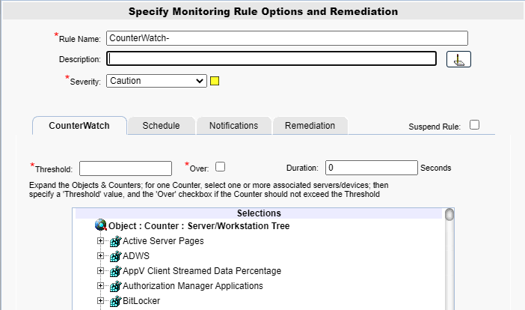

**Configure the Threshold**

1. To create a new monitoring condition, navigate to the **Configure - Monitoring Rules** page and click the **New** button
2. A selection pane will appear, select the radio button option for **Counter Watch** and then click **OK**
3. Now the monitoring rule pane will appear. At the top of the pane name the Monitoring Rule via the **Rule Name** field, as well as define the description and the severity.
4. The first tab, **CounterWatch** is where you will define what counter is to be monitored.
5. Using the **Selections** tree at the bottom, find the counter that you want to monitor. Once found, expand to select the machines that you want to monitor with this rule.
6. In the **Threshold** field, define the threshold value for the counter selected. The value is dependent on the counter and can represent a quantity or percentage.
7. The **Over** check box, works in conjunction with the **Threshold** field. When checked, the counter value must be OVER the threshold value for the specified duration for the alert condition to be met. When unchecked, the counter value must be UNDER the threshold value for the specified duration for the alert condition to be met.
   1. For example, you'd want to know when CPU is over 90% and in this case would check the box. Similarly, you'd want to know when Drive Space is less then 15%, and in this case would want to leave the box unchecked
8. The **Duration** field works in conjunction with the ‘threshold’ and ‘over’ fields. In this field, define how long in seconds that the counter value must exceed the threshold value, either over or under, for the alert condition to be met.

**Configure the Schedule**

The **Schedule** tab of a monitoring rule allows users to define how frequently the rule will alert. This can be done by adjusting the following fields:

* **Alert Every Time**: Defines whether an alert is generated every time the conditions are on the previous tab are met.
  + When checked the alert is generated every time the conditions are met.
  + When unchecked, the alert is only generated if the alert conditions are met, and the Minimal Notification Interval is exceeded since the last alert for this type.
* **Minimal Notification Interval**: Defines the minimal interval that must elapse between events for this alert before another alert will be generated.
  + The Alert Every Time checkbox must be unchecked in order to use this option.
  + For ServerWatch IP Services, this also defines the minimum elapsed time since a service is first detected as down or failed before an alert is generated.
* **Maximum Notification Interval**: Defines the maximum number of times you want to be notified during a continuous failure situation.
  + A value of 0 means no maximum is defined so you will continue to be notified according to your Alert Every Time and Minimal Notification Interval settings.
  + A non-zero value means that after you have been notified the number of times defined in the Maximum Alert Notifications, and according to your Alert Every Time and Minimal Notification Interval settings, you will not be notified again.
* **Notify On Restore**: Defines whether a 'Restore' alert is generated if you have previously been alerted due to a failure.
  + There is always a Notify on Restore for a ServerWatch for IP Service

**Additional Configuration**

For additional configuration options please see the following articles:

* Enabling Notifications:
  + [Configure Email and Text Alert Notifications](https://support.goliathtechnologies.com/hc/en-us/articles/360024446933)
  + [Configure SNMP Alert Notifications](https://support.goliathtechnologies.com/hc/en-us/articles/360024726913)
  + [Configure Syslog Alert Notifications](https://support.goliathtechnologies.com/hc/en-us/articles/360024346594)
* [Configure Custom Remediation](https://support.goliathtechnologies.com/hc/en-us/articles/360024446633)